SADDLE BROOK MAYOR’S YOUTH GROUP
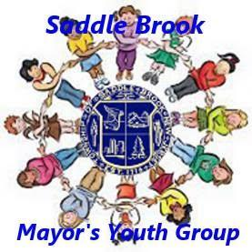

Registration Form

Name (First and Last) ______

Address ______________________________________________________________________________

Grade (September 2023) ______ School ___ __ Date of Birth ________________

T-Shirt Size (Please indicate if youth or adult size) _________________________________________________
Phone (Home) __________________________ (Work/Mobile) ______

Email _______________________________________________________________________________

Preferred Method of Contact ________________________________________________________________
Hobbies, Interests, Skills (continue on reverse side if you need more space)
_________________________________________________________________________________________

Previous Volunteer Experience (continue on reverse side if you need more space)
_________________________________________________________________________________________

What types of volunteer work interest you? (continue on reverse side if you need more space)
_________________________________________________________________________________________

How did you hear about the Saddle Brook Mayor’s Youth Group?
_________________________________________________________________________________________

