Saddle Brook Mayor’s Youth Group
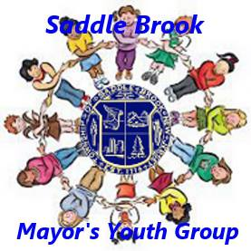
Meeting Minutes 6/26/2021

The meeting was called to order at 10:37am at Town Hall (93 Market St). We said the Pledge of Allegiance.

In old business, Thomas Van Winkle, Liaison to the Mayor and Council, acknowledged that this was our first in-person meeting since September 2020 and the first one at Town Hall since February 2020. Thomas thanked everyone for marching in the Memorial Day Parade. He also thanked the members who attended the fishing derby on June 19th.

Ideas for a summer fun outing were discussed. Several ideas were discussed, including a paint night, or outing to Monster Mini Golf or Humdingers in Paramus. Christine Genuario, Secretary to Mayor White, said an email would be sent out to all members asking them to vote on an option for a fun outing.

National Night Out was also discussed. Mayor Robert White said it would be held on Tuesday, August 3rd from 6-9pm in the parking lot of our new municipal complex (former Home Depot at 55 Mayhill Street). Christine mentioned that we will not be actively volunteering with National Night Out this year. She and Mayor White added that members could help with the table for the Saddle Brook Community Partnership table if they would like.

The next item discussed was the Mayor’s Walk. Mayor White encouraged all members to attend. It will be held on Saturday, August 28th at 9am at the Saddle Brook Park. This walk is taking place on the same day as the Township Picnic.

The Saddle Brook Township Picnic was also discussed during this meeting. It will be held on Saturday, August 28th from 12-4pm at the Saddle Brook Park. The rain date will be Sunday, August 29th – same time and place. We are asking members to volunteer to bring food to seniors in attendance. As in the past, we will have a ticket system in place for our food trucks. Christine mentioned that tickets will be available at Town Hall.

Additional business discussed included the election of officers. Mayor White suggested we could elect officers at the start of the new school year. Christine mentioned that we will vote for officers via email in the future.

At the end of the meeting, we picked the date and time for our next meeting. The youth group will meet on Saturday, July 24th at 10:30am at Town Hall, 93 Market St.

Meeting was adjourned at 10:56am.

