Saddle Brook Mayor’s Youth Group
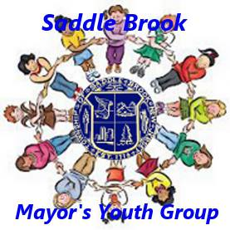
Meeting Agenda 2/11/2022

Call Meeting to Order

Pledge of Allegiance

Introduction of New Members, if any

Installation of Officers
- Tyler Pozzi – President
- Madeline Girgenti – Vice President
- Eva Shah – Secretary

Old Business

Discussion of Youth Group Events in 2022
- Easter Party – Saturday, April 16th from 12-2pm in the High School Gym
- Earth Day Activity – Saturday, April 23rd
- Saddle Brook Memorial Day Parade

New Business

Adjourn Meeting

