Saddle Brook Mayor’s Youth Group
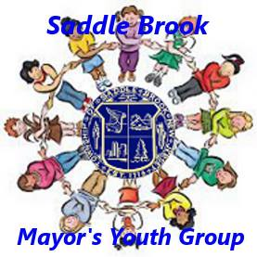
Meeting Agenda 1/22/2022

Call Meeting to Order

Pledge of Allegiance

Introduction of New Members, if any

Old Business

Discussion of Youth Group Events in 2022
- Easter Party – Saturday, April 9th
- Earth Day Activity – either on Saturday, April 16th or Saturday, April 23rd
- Saddle Brook Memorial Day Parade

Election of Officers

New Business

Adjourn Meeting

