Saddle Brook Mayor’s Youth Group
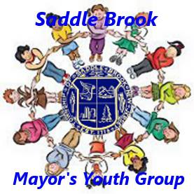
Meeting Agenda 9/26/2020

Call Meeting to Order ~ Gavin Accomando, President

Pledge of Allegiance

Introduction of New Members

Old Business

Discussion of Election of Officers

Upcoming Youth Group Events
- Trunk or Treat
  - Date and Time: Saturday, October 31st (Halloween!) from 12-2pm
  - Where: Parking Lot of Future Town Hall, 55 Mayhill St.
  - Rain Date: Sunday, November 1st – same time and place
  - No refreshments will be served.
  - Masks will be required.
- Halloween Decorating Contest
  - Deadline to register is Monday, October 26th
  - Registration list will be emailed Tuesday, October 27th to all members
  - Submit results by Halloween.
  - Winners will be announced soon after.

New Business

Adjourn Meeting

